CptS 540 Artificial Intelligence

hw11

Jinyang Ruan

011696096

1.

a.

|  |  |  |  |  |  |  |
| --- | --- | --- | --- | --- | --- | --- |
| **Iteration** | **U(1, 1)** | **U(1, 2)** | **U(1, 3)** | **U(2, 1)** | **U(2, 3)** | **U(3, 1)** |
| **0** | 0 | 0 | 0 | 0 | 0 | 0 |
| **1** | -0.04 | -0.04 | -0.04 | -0.04 | -0.04 | 0.68 |
| **2** | -0.08 | -0.08 | -0.08 | 0.44 | -0.08 | 0.74 |
| **3** | 0.26 | -0.11 | -0.11 | 0.57 | -0.11 | 0.79 |
| **4** | 0.38 | 0.13 | -0.14 | 0.63 | -0.14 | 0.8 |
| **5** | 0.46 | 0.26 | 0.03 | 0.65 | -0.17 | 0.81 |

b.

|  |  |  |  |
| --- | --- | --- | --- |
| **Iteration** | **Q(1, 1, right)** | **Q(2, 1, right)** | **Q(3, 1, up)** |
| **0** | 0 | 0 | 0 |
| **1** | -0.04 | -0.04 | 0.77 |
| **2** | -0.07 | 0.58 | 0.85 |
| **3** | 0.43 | 0.71 | 0.86 |
| **4** | 0.58 | 0.73 | 0.86 |
| **5** | 0.61 | 0.73 | 0.86 |
| **6** | 0.62 | 0.73 | 0.86 |
| **7** | 0.62 | 0.73 | 0.86 |

2.

a. $P\left("the wumpus smells the gold"\right)$

$=P\left(wumpus | the\right)P\left(smells | wumpus\right)P(the|smells)P(gold|the)$

$=\frac{P\left(the wumpus\right)}{P\left(the\right)}*\frac{P\left(wumpus smells\right)}{P\left(wumpus\right)}*\frac{P\left(smells the\right)}{P\left(smells\right)}*\frac{P\left(the gold\right)}{P\left(the\right)}$

$=0.5*0.45*0.67*0.13$

$=0.02$

b. $P\left("the wumpus is dead"\right)$

$=P(wumpus|the)P(is|wumpus)P(dead|is)$

$=\frac{P\left(the wumpus\right)}{P\left(the\right)}*\frac{P\left(wumpus is\right)}{P\left(wumpus\right)}*\frac{P\left(is deas\right)}{P\left(is\right)}$

$=0.5*0.55*1$

$=0.28$

3.

a. “the wumpus smells the gold”

Only have one parse tree

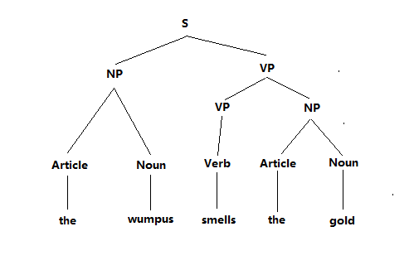

b. “the wumpus smells the gold in 2 3”

Have two possible parse trees:

* “in 2 3” refers to the wumpus

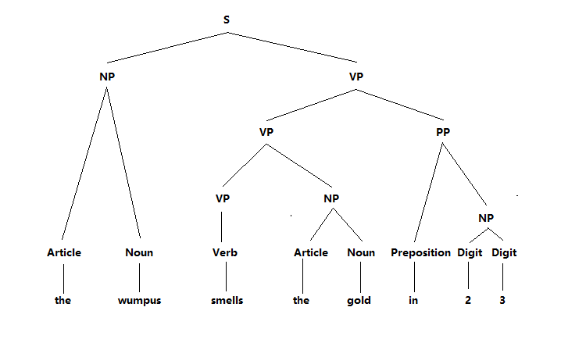

* “in 2 3” refers to the gold

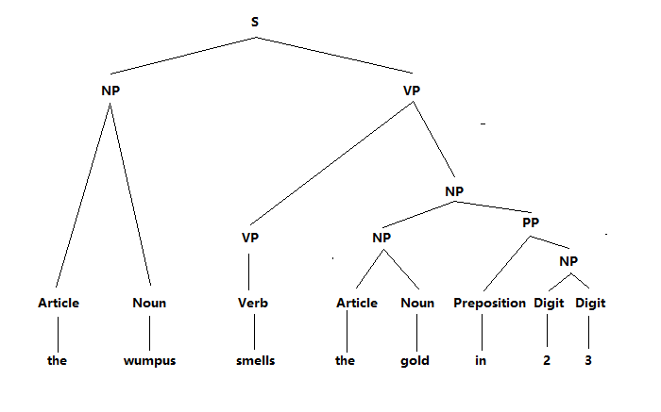

c. “the wumpus is dead”

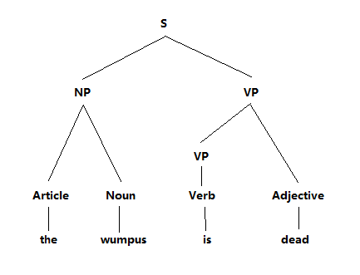

4.

a.

b.

c.

5.

|  |  |  |  |  |  |  |
| --- | --- | --- | --- | --- | --- | --- |
| **Iteration** | **U(1, 1)** | **U(1, 2)** | **U(1, 3)** | **U(2, 1)** | **U(2, 3)** | **U(3, 1)** |
| **0** | 0 | 0 | 0 | 0 | 0 | 0 |
| **1** | -0.04 | -0.04 | -0.04 | -0.04 | -0.04 | 0.68 |
| **2** | -0.08 | -0.08 | -0.08 | 0.44 | -0.08 | 0.74 |
| **3** | 0.26 | -0.11 | -0.11 | 0.57 | -0.11 | 0.79 |
| **4** | 0.38 | 0.13 | -0.14 | 0.63 | -0.14 | 0.8 |
| **5** | 0.46 | 0.26 | 0.03 | 0.65 | -0.17 | 0.81 |
| **6** | 0.49 | 0.34 | 0.13 | 0.66 | -0.05 | 0.81 |
| **7** | 0.51 | 0.37 | 0.21 | 0.66 | 0.04 | 0.81 |
| **8** | 0.51 | 0.39 | 0.25 | 0.66 | 0.12 | 0.81 |
| **9** | 0.52 | 0.4 | 0.28 | 0.66 | 0.18 | 0.81 |
| **10** | 0.52 | 0.41 | 0.3 | 0.66 | 0.19 | 0.81 |
| **11** | 0.52 | 0.41 | 0.3 | 0.66 | 0.21 | 0.81 |
| **12** | 0.52 | 0.41 | 0.3 | 0.66 | 0.21 | 0.81 |